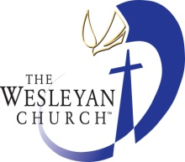Montrose Wesleyan Holiness Church

278 Penco Street, Lange Park

Chaguanas

(868) 672-6054

7/25/2017

**To Whom It May Concern**

This is to certify that I have known **Ms.Afiyfa Punnette** for the past ten years and I have found her to be very honest. I hereby confirmed that during the period May 2015 to February 2017 she was self employed as a Hairdresser as was stated in her application. Whilst it was difficult, she was fortunate to keep herself busy, as she endeavour to make an honest living to meet her obligations. Afiyfa Punnette is a very hard working, motivated, willing and honest individual. After years of seeking a stable job, she has now found a job that motivates her which can enhance her on a career path.

Sincerely

…………………………..

Mrs. Tabitha Chichester

Church Secretary.2000000